Project | Opencart
Tested by | Vishwa
Test Execution Date | dd-Mmm-yy
Test Cycle | 1
Test Environment | localhost
Version, Release, Build Number | 1, 1, 1
Test Scenario Number | TS0001
Test Scenario | Register Functionality
Test Case ID | TC_RF_0001
Test Case Description | Validate Registering an account by providing all the fields (Mandatory and Non-mandatory fields)
Test Steps | 1. Click on 'My Account' drop-down menu  2. Click on 'Register' option  3. Enter new account details into all fields(First Name, Last Name, Email, Telephone, Password, Password Confirm, News letter, Privacy Policy)  4. Click on 'Continue' button(ER-1)  5. Click on 'Continue button displayed in Account Success page(ER-2)
Test Data | Not Applicable
Expected Result | 1. User should be logged in and navigated to Account Success Page and proper details should be displayed on the page.  2. User should be navigated to Account page.
Actual Result | As Expected
Test Result | Pass
Bug/Defect ID | Not Applicable
Steps to Reproduce | Not Applicable

1. Click on 'My Account' drop-down menu
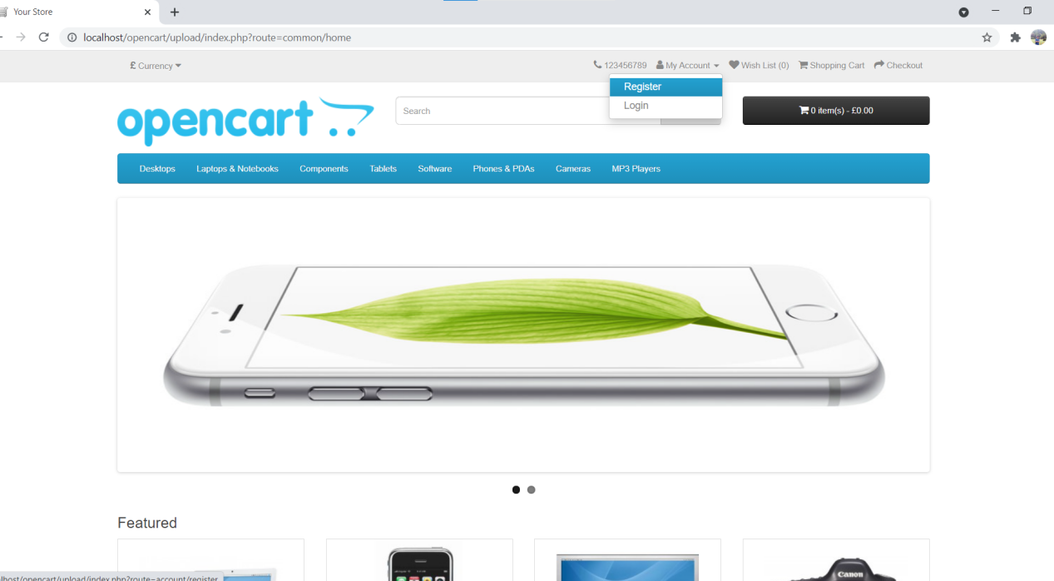

2. Click on 'Register' option
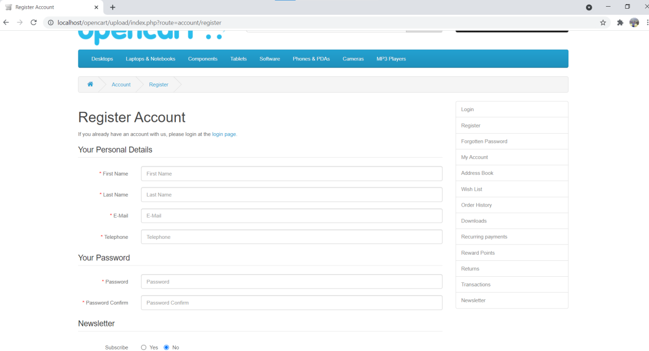

- Enter new account details into all fields(First Name, Last Name, Email, Telephone, Password, Password Confirm, News letter, Privacy Policy)
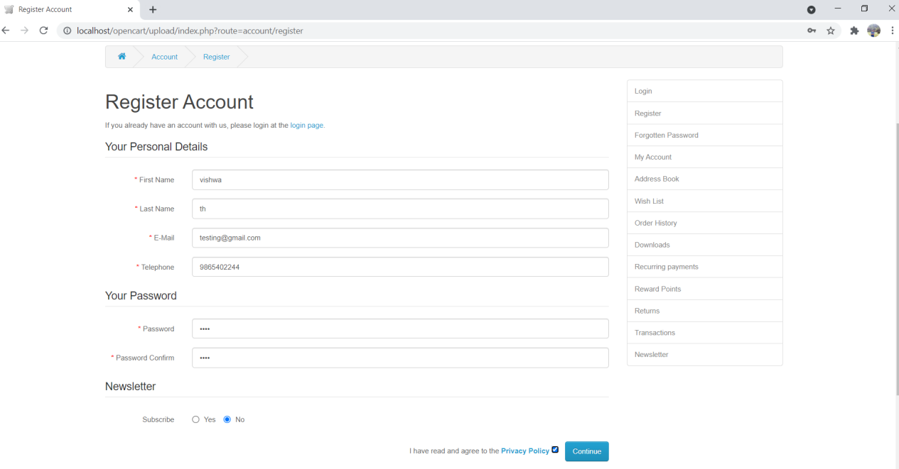

- Click on 'Continue' button(ER-1)
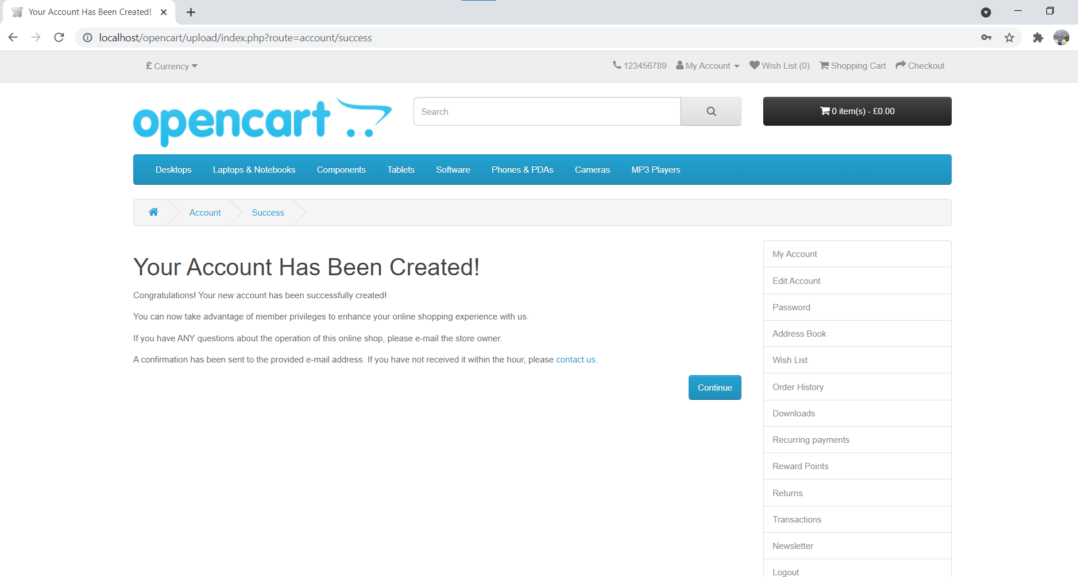

- Click on 'Continue button displayed in Account Success page(ER-2)
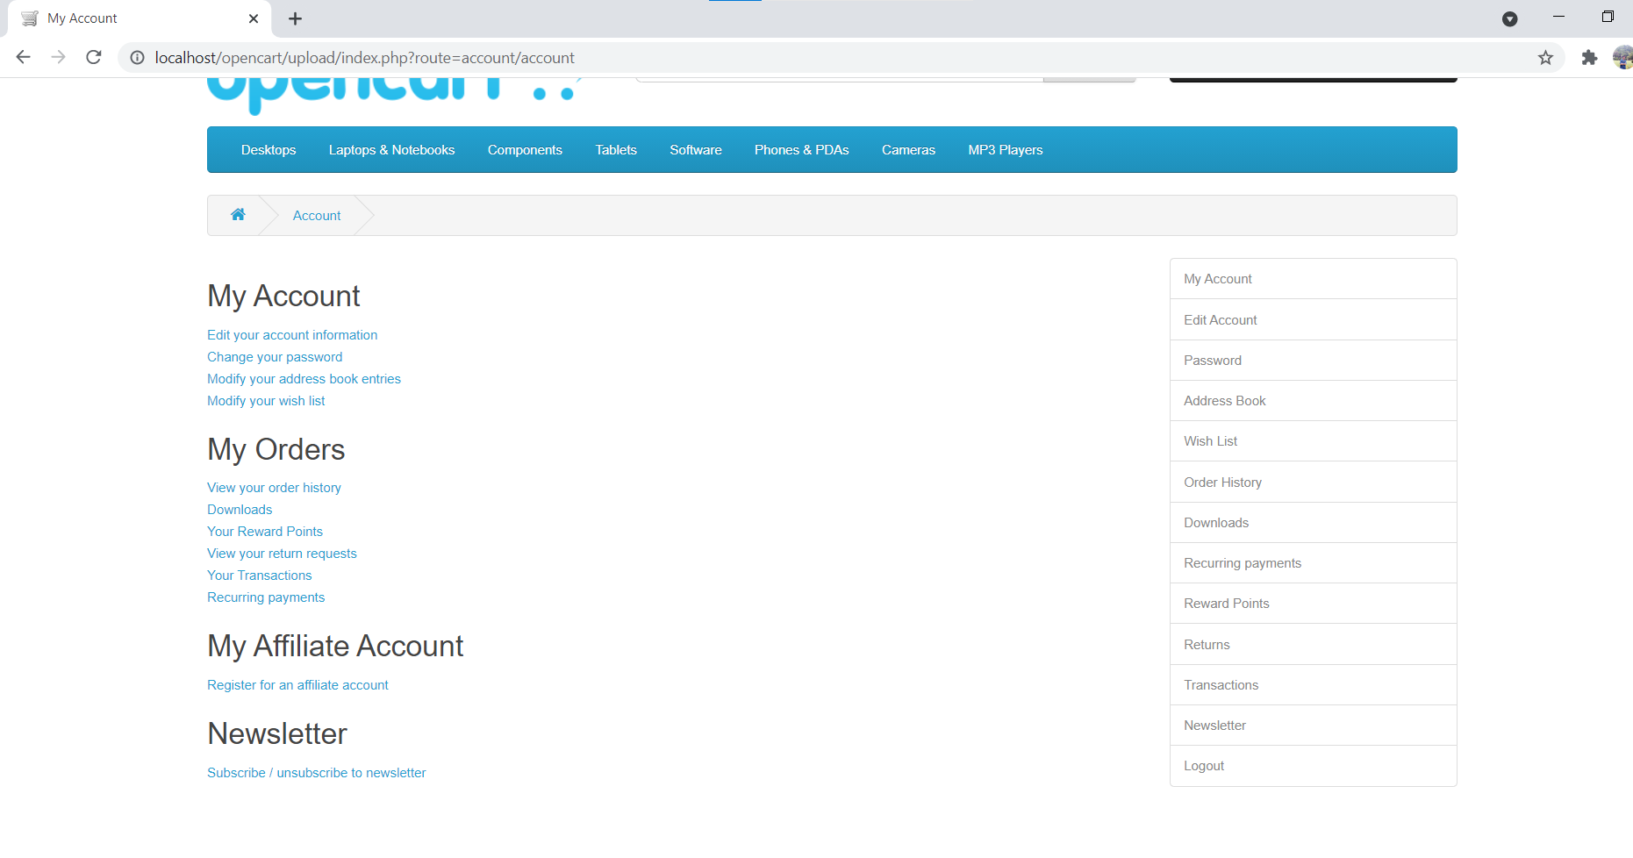

After registration, Confirm email received in mailbox (to be saved in test result folder as a evidence)

